**I. EXECUTIVE SUMMARY**

Celestial is an apparel and accessories retail business focused on keeping ages 13-21 in trend through customer interactions. With just $103,999 of investment and $107,369 of business equity, Celestial is ready to take lead in the apparel industry. The loan is paid in the spread of 10 years with the interest of 7 percent. Therefore, Celestial’s monthly payment is $1238. In another words, the investment will have a return of estimated $81,363 in those years. This value is not just a fantasy. Celestial has the plan below assuring the success of the business.

First, Celestial has the opportunity to flourish due to its location. It is placed between urban area between Lynnwood and Bothell. Celestial is promising due to its unique selling points. Celestial always has the top 20 brands and styles of the month followed by personal Celestial brand. No clothing retailer provides both name brand and corporate brand products like Celestial does. Celestial thrive to be the best by conducting periodical market research to keep the product line appealing. On corporate brand products, Celestial will make designs that majority of the customers would like to wear themselves. They can upload requests online or at the store. Celestial voices the customer’s innovative ideas and directly meets their wants. Making products that customers want is a guaranteed way to generate sales.

Celestial is strategic when it comes to plan of operation as well. Celestial opens 30-60 minutes later than its competitors so indecisive customers can come to Celestial after leaving the competitor’s store empty handed. Celestial is aware of low sales in weekday mornings so it opens later than most stores. This saves unnecessary utility and employee expenses.

Celestial trains all employees with professional training for each position: manager, cashier, and organizer. High expectations in human resource lead to exceptional customer services. All employees treat every customer with appropriate selling process to build customer loyalty. Celestial also utilizes competitive advantage. Celestial sets itself as a quality store because pricing is in standard with the competitors. This shows that the store is confident just with its uniqueness and promotions. With ten years of experiences as a marketing professional and in the human resource department at Zumiez, Celestial is qualified to create damage on 10 percent of the market share in the beginning years. Even though Celestial projects a planned loss of $106,643 until the break-even in the 11th month, the profit made the next three years will soon make the losses into value.

The use of all promotional mixes and creative plans grasp the target market. The attraction makes decrease in sales absent in Celestial. Promotion includes costly advertisements, personal selling, publicity, and timely sales promotion. They all inform the prospects with goods and services Celestial provides. Promotions also share deals and offers Celestial has in appreciation of every single customer. These types of various promotions will get the number of sales in rhythm.

With the mind to serve the customers with Celestial’s firm criterion, Celestial differentiates itself from the competitors and expects continuous growth every year. No better investments can be made than in Celestial, a business that thrives ‘to generate both existing and personal branding to take the lead on the clothing industry.’

**II. INTRODUCTION**

Tired of the same old apparel and accessories industry? Of course you are. In fact, you are probably looking to invest on businesses that are indifferent with the littlest hope for positive results. However, Celestial is the type of business that you should be volunteering to hold hands with. With innovative ideas to generate revenue and willingness to create positive customer relationship with every single prospects, Celestial can be up and running with your investments. With this plan, I want to introduce my capacity and character along with what Celestial is willing to provide. Following, I want to fully flesh out the most valuable information, the projected growth and gross profit. I say ‘introduce’ because the amount of impact I will have on the fashion market through Celestial will be well beyond this plan. The following lines will describe the brief overview of ‘who, what, where, and why’ in order for you to have a grasp on what you will be working with in just couple of months.

Who you are working with, is me, a formal director at the HR (human resource) department at Zumiez, who happens to be my main competitor. I also marketed and promoted many apparel items as a business professional, therefore I have a firm idea of how business is operated. I have managed inventory that valued up to $180,000, recording for all the sales made by the company weekly. Moreover, I purchased over $55,000 of clothing lines and supplies, communicating with different vendors to find the best deal for each order. Lastly, I bring with me the partnerships in the financial and operation areas from auspicious work experiences. Having dealt with countless number of customers and business conflicts, operating Celestial will be like another day at the office.

What you are working with, is apparel and accessories retail with unique selling points. Celestial’s cause is based around exceptional customer service. For this reason, Celestial provides a corporate brand with designs based off of customer suggestions along with other brand recognized products. I conduct a research regularly to have knowledge on the trend. This way, Celestial stays on top of all changes the fashion industry goes through.

Where you are working with, is at Lynnwood. Lynnwood is abundant with apparel stores, especially influenced by the Alderwood Mall. However, the location of Celestial is away from major sales area yet is very busy throughout the day with traffic. Filbert Road which runs right in front of the store connects three major cities of Lynnwood, Bothell, and Mill Creek. This makes it suitable for growth opportunities for any particular business.

Exact Location of Celestial

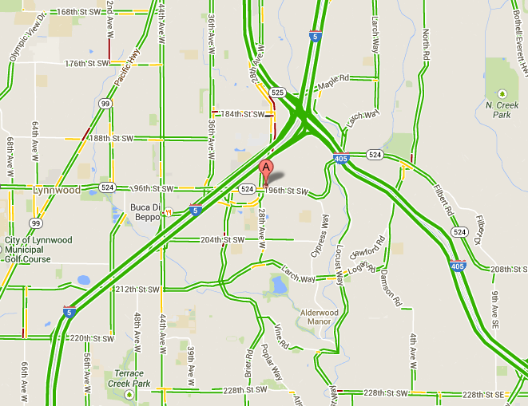

← Celestial is located next to major highway/freeway (I-405, I-5) and is at the center of three cities. The thickness of the road on the map indicates the traffic. As shown, a lot of traffic is engaged within the business’s radar. Traffic of the location is important to the number of customers and promotion.

Why you are working with Celestial, is the innovation. No franchise apparel store in the state has both corporate brand and other brand products. The theme of galaxy employs the mysterious and attractive factor for customers to enjoy. The display of products is also the strength of my business. By forming an experienced team and carrying the creativity to action, Celestial insures the satisfaction under your investment.

These are just the minimal aspects of Celestial which will be later covered under scrutiny. Through this outline, I propose the importance and effect of your investment more in detail. I have worked long enough in my past career to acquire half of the projected expense required to start my business. I have gotten financial support from family and other relationships as well. As a hardworking and honest individual, I assure that the probability of Celestial’s success is certain. Working sincerely with different apparel and accessories industries all my 20’s have set me up for this entrepreneurship that I desire to franchise, and become the paramount over all other competitors.

Apparel Store Set Up and Popular Brand of 2014

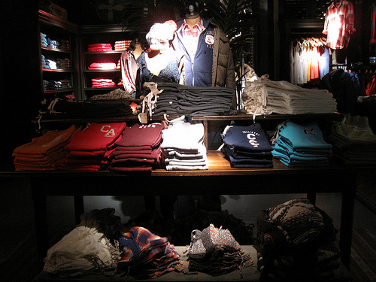 

↑ (Left) Hollister apparel retail is shown. Hollister’s display style is the closest to Celestial’s. Celestial will have dark and constellation theme corresponding to the business name ‘moon.’ The store doesn’t let any sunlight in as a way to capture the customer from leaving because they notice that the sun has gone down. This is a common tactic used by apparel stores as well as casinos and restaurants. (Right) The name brands from PacSun apparel are shown. These are the most popular clothing lines that my demographics, ages 13-21, recognize and buy. Celestial will negotiate with these vendors and sell similar products along with personal Celestial brand.

**III. ANALYSIS OF THE BUSINESS SITUATION**

1. **Trading Area Analysis**

Celestial is extremely strategic when approaching the market. The target market of Celestial is young adults from ages 13 through 21 whose household is able to make over $70,000 per year. Since Celestial provides high quality products with the newest trending designs, it is affordable to mostly financially supportable household. The geographical feature shown in the map previously allows the market from three different cities. Therefore the customer base consists of 21,000 people according to the U.S Census Bureau (Bothell). This is a great advantage because public recognition can spread much quicker throughout the target audience at variety of schools. Estimated 80 percent of the projected market will come from the five mile radius from the store therefore the promotions will be focused in this area. Having planned outlook expects Celestial to grow to take at least 10 percent of the market share or 2,100 customers in the apparel retail within in the first year.

Example of Target Market in the Competitor Store, Zumiez

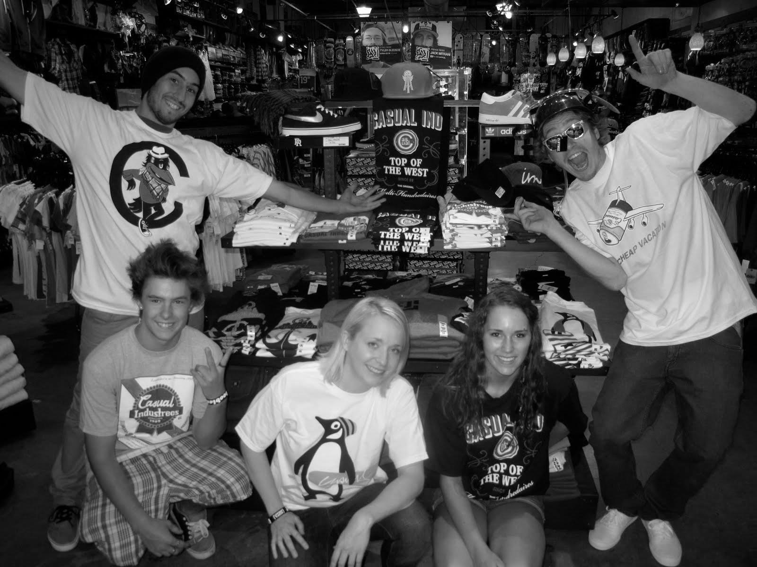

↑ Above is an example of type of customers that Celestial will create a business relationship with. This is direct photograph from the customers from Zumiez, one of our main competitors. It is noticeable the satisfaction the customer have with the store. Along with Zumiez, Celestial will provide great customer service to each individual who walk in the door. Celestial understands the value of each target market, each customer, and each sale. Similar to Celestial, it is coincidentally represented that more guys shop at a trending store. The reason is because guys follow trends and girls make their own trends.

1. Geographic and demographic information

More on the target market, Celestial provides slightly more male based products in the store making the ratio of male to be 60 percent of the revenue made. Providing top 20 brands such as Diamond and Obey (Walano) to the target audience is the most important aspect of Celestial. Some brands Celestial works with are listed in the appendix (28). Celestial will reach out to the public and collect not only secondary data off of the browser but personal primary data with prospects. Survey will take place around areas where the market gathers along with the online campaign. For example, the nearby Alderwood Mall during the weekend is a great place to start the survey. Survey composes of straight forward questions such as ‘what is your favorite brand and why?’ or ‘what is the noticeable trend at school?’ Knowing what kind of customers to expect and what they want already helped to decide which vendors to purchase the products from.

The geographic advantage of Celestial is the location in respect to schools. All the target audience is going through high school, some college, education. Now, Celestial is at the center of Shoreline, Edmond, and Northshore School District and nearby many community colleges. Living in Washington all my life, the three of the most diverse groups of young adults in Washington live within close proximity of the store. The passion for fashion in these kinds of areas resulted in growth of apparel sales almost exponentially (Larson). Therefore Celestial, with its unique selling point and exceptional customer service would be a positive addition to the market.

Celestial’s location is not only beneficial due to school. Celestial has no direct competitors within five miles radius of the store. The Old Navy, two miles away, went out of business recently due to lack of popular brands (Nguyen). However, many customers used to go to the store regardless because of the convenient location. Celestial, attaining both favored location and popular products, is assured success with the given demographics. The prominent Alderwood Mall is a little away from Celestial and is very crowded. Customers generally like the isolated and more focused store which is why Celestial would be the first choice over the other competitors. (Larson) Celestial’s layout is drawn in the appendix (29).

Different Apparel Store Locations (Group vs. Isolation)



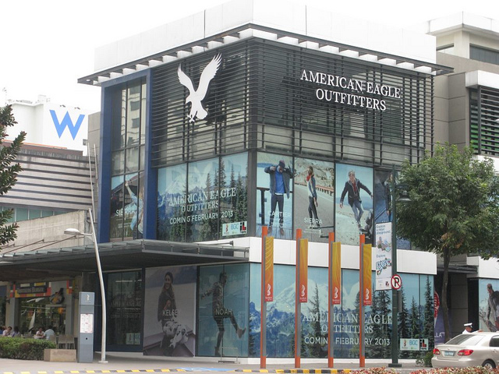

↑ Pictures above are contrasting the Alderwood Mall and the separate building of American Eagle Oufitters. The advantage of an isolated building like the American Eagle or Celestial is that it is easier to advertise and spot. Also isolated buildings create the sense of professionalism that clustered stores in malls and outlets cannot.

Most demographics are allured to special structure of all the similar apparel retailers. Architectural difference to spatial benefit can be all demonstrated from the two photos above. Celestial is going to utilize all geographical benefit and isolation is definitely a unique aspect, especially in a crowded world of today.

1. Market segment analysis of target market

The target market is generally not able to afford the products that Celestial provides therefore they need to rely on their parents. Teenagers are usually influenced by their own friends therefore it is more effective to advertise to the so called “trendsetter” of the group. (Fashion) The goal is to reach out and first create public relations since Celestial sells corporate brand along with the name brands. It is an undeniable fact that with the resources and ideas that Celestial make available, Celestial has the potential to take the lead in the market and become the paramount over other competitors

1. **Competitors**

Competitors include Hollister, H&M, Abercrombie, Urban Outfitters, Zumiez, and Pacsun. These are all located near the Alderwood in city nearby such as Woodinville. It is crucial to know their strengths and weaknesses to surpass them. They all provide either corporate brand or name brands in their store but not both (Nguyen).

1. Primary competitor’s strengths and weaknesses

Competitors in the retail industry are extremely hard to take the market share from. The most obvious strength of my competitors is name brand recognition. There is a very few chance that people are going to pick a local brand compared to Nike. Therefore it is essential for Celestial to really take into consideration the voice of the customers. Also the strength of already existing market such as Zumiez is that they are supported and has a strong customer base (Lewis). Most of these competitors are financially stable and in continuous growth.

The competition also has relationships with renowned manufacturers and can make mass products rapidly. Having the relationship from previous work experience with fabric industry, Celestial is able to negotiate with vendors as well. H&M has a very similar idea as Celestial does (Nguyen). They consist of corporate brand along with name brands which is the only store out there that does this. Celestial is the only other store that provides this. So the job of the Celestial is to compete with H&M with customer relationship. There are no workers in these franchise stores who roam around to connect with the customer. Also, H&M provides brands that are off customer’s want. The employers and the store’s productivity are the difference that will give positivity and increase of revenue (Lewis).

1. Competitive advantages and disadvantages of the proposed business

However, there are in fact some aspects that even the most famous fashion store lacks. It is creativity and innovative thoughts. Most competitors are blending in and it is difficult to identify their unique selling points. It is because the target market generally wants similar items. Taking this information, Celestial will make corporate brand with customer’s want and not only that, they can choose between the market’s most popular brands. Corporate brand is an excellent way to have customer relationship and more profitable approach (Farese 568). Giving the target audience more options to choose from is always beneficial to the society and to the store. The fact that the only other store to provide unique brand and only the popular brand products out in the apparel industry is Celestial and H&M is what makes Celestial have the chance to take the market share away. The competitive advantage is that it lets the customers know the unique selling point of Celestial and the disadvantage is that the customers already have loyalty to name branded stores. Features and benefits of Celestial are in the appendix (30).

Example of Celestial Corporate Brand Product

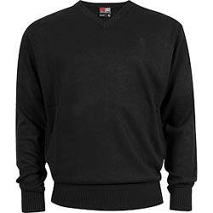

← This is an example of type of designs that Celestial’s corporate branded product will manufacture. This design is based on the fact that the target market likes the fullness of the crewneck shirt and unique factors like writings on the laces. Knowing the different options when manufacturing and what the target market wants, it is quite simple to have success with a personal brand.



**IV. PLANNED OPERATION OF THE PROPOSED BUSINESS**

1. **Proposed Business and Organization**

Celestial’s approach to the retail market is envisioned a success due to its organized plan of business operation. The mission statement for the Celestial is ‘to generate both existing and personal branding to take the lead on the clothing industry.’ To achieve this, Celestial has determined that they are in need of time and energy to bring the customers to the door. Celestial’s opening hour is the following:

Celestial Open Hours

Mon-Sat: 9am-9pm

Sat: 12pm-10pm

Sun: 12pm-8pm

The reason for 9am start during the weekdays is that it is an hour earlier than most apparel stores’ open hours. The mall always opens at 10am, therefore it is almost natural for customers who are heading out to the mall to stop by and shop at Celestial. It is manageable time for early customers to visit who are busy during the afternoon and evening. Having advantage of the early customers before the competitors can generate considerable amount of profit and take some market share. The 9pm closing hour is a safe time for the teen market to shop without catching themselves too late. This also gives time for the employees to clean and organize without stressing them a lot. These reasons are why standard retail industries close at 9pm.

On Saturday, late 12pm opening take into account that the most of the target audience would sleep in during the weekends. Working at Zumiez, it was apparent that 10am starts on Saturday was ineffective and costly. The reason for later close of 10pm is that the customers are able to shop longer at Celestial than any apparel stores nearby. On the weekends, there is no pressure for early return home and people tend to make abrupt decisions later at night. Giving the customers more time to decide and compare prices with usual apparel stores that close at 9pm is a great way to lead the evening time customers to make final purchase at Celestial instead of other stores. Lastly, the Sunday is similar to Saturday; however closing at 8pm is way for customers to relax the last day of the weekend by closing earlier. Like this, Celestial chooses everything, even the open hours, based on the customer’s convenience.

During these open hours, employees are the important factor in operating Celestial. Without each required job positions, no sales are possible. They hold the key to running the business and forming positive customer relationships. Celestial has three necessary positions: full time manager, either full time or part time cashier, and part time organizer. Manager is accountable for management, inventory, advanced cash register software, and marketing research. Managers are the most reliable source in the business and they are able to run the business without major leadership (Farese 16). The trainings for the manager position are done mostly before working in the position and some during. However, as a previous human resource manager, all hired workers in Celestial acquire most of the skills beforehand. Some examples of trainings include class for leadership and management, role play of inventory control in business situation, and technological guide for computer programs (Berman 386).

Example of Celestial Employee’s Responsibility

← This is an example of a store manager in JCPenny taking care of the cashier job with efficiency and ease. The experience gives confidence to the manager as she show no sign of anxiety with the customers. Celestial’s managers are no different. Hired managers will show great attitude and take on rigorous assignments that will affect the drive of the business. Managers serve as multipurpose individuals and can be trained to be trainers

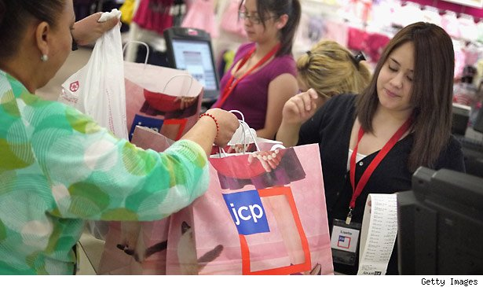

Cashier job is done by managers but also by specific person holding the cashier position. Cashiers are continuously taught of the selling process. They practice pre-approach, approach, determining the needs, presenting, dealing with objections, closing the sale, suggestive selling, following up, and following through daily with customers. They are also able to provide great service through telephones and handle products, sound system, and surveillance. Lastly, the organizer resupplies, folds, hangs, and cleans the store. These are very easy to pick up if the worker is diligent and obedient. Celestial takes appearance into regards with the employees. Having employees who can bring out Celestial’s product by being able to model them during the work hours can be a costless attraction for customers.

Example of Employees

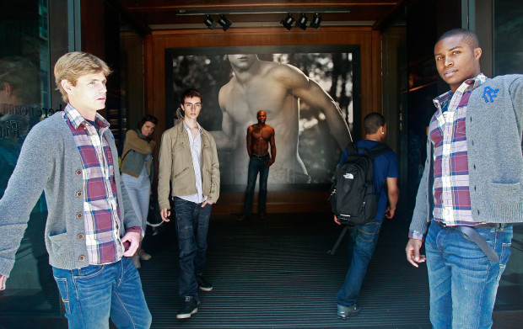

↑ Above is an example of how appearances of employees serve as a great promotion factor in Abercombie. Welcoming and appreciating each customer that step through the door is an important task as any employee. All Celestial workers will show such unity and benevolence to each customer. These workers are able to accomplish sales by interacting with customers with comfort and holding answers to all questions.

With the different load of work and responsibility, manager is paid $20 per hour, cashier $18 per hour, organizer $15 per hour, higher than regular retail (Fashion). Full time employees are paid monthly salaries and part times are paid every two weeks. (Berman 386). The addition of employees is crucial to the expenses of Celestial. First year, two managers and I are running the business. When Celestial hits the break-even point, which is projected to be in the 11th month, a part time employee will be added starting the second year. To keep the employees faithful to Celestial, there is a wage increase after six months of working. This will motivate all workers to their best effort which would increase the productivity.

Working with Celestial, all full time employees get a 35 percent benefit for insurance, business education, and more. Providing business education might set up the road for the employee’s advancement and promotion (Berman 37). Employees moving careers by great opportunities given from Celestial will leave good testimonial and positive image to the business.

1. **Proposed Strategies**

Even with superb customer service, the materialistic products are the actual needs of a customer. Therefore without reasonable pricing and promoting, the operation is not useful at all. Pricing and different types of advertisements are good portions of the expenses and they are necessities (Berman 67). Therefore utilizing the power of the two aspects can lead Celestial to an increase in sales. The proposed strategy for pricing is maintaining the average retail price while using the aid of various promotional types. This tactic keeps Celestial from being referred as an inexpensive store and brings in the customers by endorsement.

1. Proposed pricing policy

Celestial’s pricing is determined by the competitors. Upselling or selling at a higher price than the standard pricing is a stretch for a new business. Also, selling at a lower price can attract customer in the beginning, however it is difficult to keep that price in the long run to stay in business (Larson). Soon the business will have to raise the price which can cause dissatisfaction to the existing customers. With similar retail as other apparel stores, the product category and the approximate price would be like this:

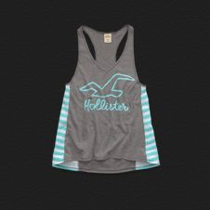Product Line and Approximate Price

|  |  |  |
| --- | --- | --- |
| http://picture-cdn.wheretoget.it/mehyj5-i.jpgShirt: $18 | Tanktop: $12 | https://images.lululemon.co.nz/is/image/lululemon/LW5B78S_0001_1Leggings: $40 |
| https://s3.amazonaws.com/mno.products/14248/ab048c2411.jpgCrewneck: $32 | http://the-safe-house.com/blog/wp-content/uploads/2012/05/converse-all-star-ox-optical-white-2.jpgShoes: $70 | http://indul.ccio.co/hy/bh/3e/176836722838264715SOU9KiPac.jpgYoga pants: $60 |
| http://tshirtsky.com/media/catalog/product/cache/1/image/9df78eab33525d08d6e5fb8d27136e95/1/1/1111111111111.jpgSweatshirt: $45 | http://www.lawyersandsettlements.com/blog/wp-content/uploads/2011/05/skinny-jeans-guy.bmpJeans: $38 | http://cache.theoutnet.com/images/products/40892/40892_in_xl.jpgCardigan: $32 |
| http://media-cache-ak0.pinimg.com/736x/b7/4a/c3/b74ac3c78fac301e544014e0001cdc9b.jpgFlannel: $20 | https://s3.amazonaws.com/assets.svpply.com/large/1411054.jpg?1389252181Underwear: $15 | http://24.media.tumblr.com/tumblr_mawdk2g7O11rxwvnbo1_500.jpgBackpack: $40 |
| http://rebulcollection.com/xcart/image.php?type=T&id=39Hats: $20 | http://www.valentineperfume.com/images/P/t_22964.jpgCologne: $15 | http://forums.watchuseek.com/attachments/f17/662564d1332713512-best-looking-white-g-shock-ga-110c-7ajf.jpgWatch: $90 |

However, this doesn’t mean Celestial won’t ever change prices. If Celestial remains a constant retail price of a product for a month, it is possible to adjust the price for economical or promotional purposes. (Farese 461-462) Celestial will always be on track with the supply and demand and up to date with price changes in the retail business. Also, the Celestial’s personal brand will be sold in slightly lower price than others because the profits go straight to the business without giving expense to the vendors. Like this, the pricing policy is totally up to the competitors and the value of the clothes as trends keep transforming.

1. Proposed promotional program

Now, the question is, how will the customers know about Celestial? The features and benefits of Celestial are not going to be carried to the customers without help of promotions. Therefore strategic usage of the four types of promotional mixes can draw that first customer to the door on February and increase the sales continuously each month.

“[The] four basic types of promotion [are] personal selling, advertising, sales promotion, and public relations” (Farese 299-301). Celestial is planning to invest significant amount of the profit on advertising such as radio ads or YouTube ads. These can spread the existence of Celestial and its unique selling points using short attention grabbing videos. This is the quickest way to inform the target market who regularly turn on the car radio or the YouTube web. Celestial can buy minimal time slot for ads in popular stations or videos at first due to financial shortage. Moreover, the duration and number of times can increase gradually which can help make it through at least six months with majority of the target audience knowing about Celestial.

Personal selling can be done by physically approaching the prospects in busy streets or schools. Showing positive customer mindset and sharing about Celestial’s ability to provide needs of the customers can be really shown through this promotion. For example, having stands to hand out any brochures or answer any question, is an effective way to have the customers to feel the pressure to visit the store.

Publicity is the need for creativity and innovative ideas. (Farese 301) Some plans Celestials have is taping logo or littering business cards in the geographical area where Celestial’s market comes from. Also, website and blogging are both great ways to connect with the customers. Celestial is providing not just a factual web but a conversational place where the customers’ voices can be heard. Publicity can also be accomplished by following the mission statement and retaining positive image for the Celestial brand.

Lastly, sales promotion is going to be utilized in all months. It is an undeniable fact that all customers like discounts. Printing of coupons and having seasonal or monthly discounts can keep the customers flowing through the door. Celestial takes advantage of all holidays and events like back-to-school to increase profit and customer base. More options of promotions are listed below that Celestial is going to accomplish.

Celestial’s Promotional Program-1st year (Each Month from February 2015-January 2016)

|  |  |  |  |  |  |  |  |  |  |  |  |  |
| --- | --- | --- | --- | --- | --- | --- | --- | --- | --- | --- | --- | --- |
|  | Feb | Mar | Apr | May | Jun | Jul | Aug | Sep | Oct | Nov | Dec | Jan |
| 1. Business card | x | x | x | x | x | x | x | x | x | x | x | x |
| 1. Poster | x |  | x |  | x |  | x |  | x |  | x |  |
| 1. Flyers/catalog mail | x | x | x | x | x | x | x | x | x | x | x | x |
| 1. Special events |  | x |  |  |  | x |  |  |  | x |  |  |
| 1. E-mail | x | x | x | x | x | x | x | x | x | x | x | x |
| 1. Website/Blog | x | x | x | x | x | x | x | x | x | x | x | x |
| 1. Small Billboard | x | x |  |  | x | x |  |  | x | x |  |  |
| 1. Bus banner |  |  | x |  |  | x |  |  | x |  |  | x |
| 1. Twitter | x | x | x | x | x | x | x | x | x | x | x | x |
| 1. Radio Ad | x | x |  | x |  | x |  | x |  | x | x |  |
| 1. YouTueb Ad |  |  |  | x |  |  |  | x |  |  |  | x |
| 1. Coupon | x | x | x | x | x | x | x | x | x | x | x | x |
| 1. Giveaway | x | x | x |  |  | x |  | x |  | x |  | x |
| 1. Google AdWord |  | x | x | x | x | x | x | x | x | x | x | x |
| 1. Press release | x | x | x | x | x | x | x | x | x | x | x | x |
| 1. Sales discount | x | x | x | x | x | x | x | x | x | x | x | x |
| 1. Calendar |  |  |  |  |  |  |  |  |  | x | x |  |
| 1. Stands | x | x | x | x |  |  | x | x |  |  | x | x |
| 1. Newsletter | x | x | x | x | x | x | x | x | x | x | x | x |
| 1. Model | x | x | x | x | x | x | x | x | x | x | x | x |

Examples of most promotions listed above are shown and descriptively explained in the appendix (31-35). Utilizing all the promotional mixes and approaching the prospects even months before the store opens explains why this investment is worth it. The convincing promotion is the strongest aspect of Celestial’s plan and is what will lead to money in the pocket and initiate business relationships between Celestial and the customers.

**V. PLANNED FINANCING**

1. **Start-up Costs with On-going Expenses**

All businesses require money to get the store up and running. It is no different for Celestial. Celestial’s projected start-up cost is $103,283 with expenses that are paid monthly. Smart financial goals have to be utilized to carry the business into planned success. Celestial has finance partnerships that are able to change accounting results into meaning. With external help, every penny in the start-up cost contributes to Celestial’s operation.

**Celestial**

**Start-up Cost**

**February 2015**

|  |  |
| --- | --- |
| **Line Expense Item** | **Costs** |
| Draw (1 month) | $3,000 |
| Benefit (1 months) | $600 |
| Two Full Time Wages (1 month) | $6,400 |
| Benefits Employees (1 month) | $2,240 |
| Insurance | $500 |
| Retail Inventory (3 months at cost) | $46,620 |
| Supplies | $300 |
| Advertising (2 months) | $5,346 |
| Loan (2 months) | $2,477 |
| Maintenance | $500 |
| Lease (2000sqft*30)/12 (2 months) | $10,000 |
| Equipment for Store | $4,000 |
| Store Polishing | $500 |
| Furniture | $12,000 |
| Computer and Registers | $5,000 |
| Utilities | $100 |
| Postage | $200 |
| Phone | $200 |
| Internet | $100 |
| Miscellaneous | $200 |
| **Total Start Up costs** | $103,283 |

Total Start-Up Costs: $103,283

Total Dollars needed to Break Even Point (BEP): $107,369

Total Dollars needed for Start-up & Up to BEP: $210,652

Total Dollars owner is investing into the business: $106,653

Total Dollars needed to borrow for the business: $103,999

Most of the line items in the start-up cost need some explanation. First of all, draw of $3,000 is taken out per month to pay myself for the hours put into Celestial to keep the business alive. To run the business, Celestial selects two skilled individuals who get trained into the manager position. Starting from the beginning, a benefit of health plans, education, and daycare are covered for me and the employees. This keeps employees loyal. Benefit costs serve as a little bribery necessary to survive the difficult first year (Berman 37).

Celestial needs to pay consistent monthly fees the moement business opens since it is a property. The most important payment is the lease of $5,000 a month. This gives ownership to the Celestial property. Utility charges for electricity and gas, property insurances, and inspections are also spent in order to start and maintain a quality clothing business.

Celestial has payments that are only required at the beginning to get the store set up for that first customer. First of all, the two essential items in a clothing store are starting inventory and furniture for displays. The product and a place to put the product make up almost everything in the store. That explains why the costs of these two line items take up greater than 50 percent of total start-up cost. The other necessities of Celestial are computers and cash registers which is responsible for all transactions and data storage. These high technological machines easily cost $5,000. Office supplies and postages are also crucial in completing tasks that require a specific tool therefore contributing to the money needed.

Celestial relies a lot on its visual setting because recent studies show that teens are drawn into an apparel retailer by the surrounding background or sound (Larson). To take advantage of this conjecture, Celestial pays portions of expenses for store polishing and decorations which is included in the miscellaneous. Celestial provides a theme of universe which derives from name of the business, Celeste, or moon. With dark environment, it saves a little on electricity yet creates a mysterious environment that my market enjoys. However, significant amount of flashy lightings are required for visibility and visually pleasing light movements costing up to $200 per month.

Lastly, customers recognize advertisements that retail businesses invest in, along with extra services. To develop solid customer base consisting of 10 percent of the target market, Celestial is using 10 percent of the projected revenue for the year on advertising. The reason for such significant investment is shown by the different types of promotional approaches Celestial has in the plan. An extra service that grasps all teens today is internet. Having local Wi-Fi is a powerful way to pull customers who are out and about in to the customer and force a look around the store. With just $100 per month, Celestial is able to provide a commanding service to the customers. All needed items are listed in appendix (36).

Investment of $103,999 that Celestial attains from you will be mostly used in paying the start-up cost. Moreover, it is clear from the analysis above that Celestial is not wasting any part of the investment. Every expense has its own function and fulfills the requirements needed for Celestial’s future success. With this wise distribution of expenses outcomes a fairly low start-up cost of $103,283. Still, it has the opportunity to grow and serve as a powerful independent business. Celestial does not believe in stinginess. It believes in management. SMART (specific, measurable, attainable, result-oriented, and time-bounded) goals are what make Celestial so decisive.

1. **Projected Cash Flow Statement for First Year**

Celestial projects a total net loss of $100,269 in the first year. This may sound detrimental but planned loss isn’t a huge concern. The main progress reached in the first month is shown when Celestial reaches its first break-even point on the 11th month.



There are numbers to be discussed in this cash-flow statement. First, the revenue is projected to increase about 10 percent each month due to the continuous build of the market share. Celestial is confident that majority of the customers will find preference in Celestial after the sale. Starting from estimation of $30,000 revenue, the revenue by the end of the year is $85,594. This $55,000 increase in revenue is the effect of $5,346 per month that goes into advertisement combined with hard work. In retail, cost of good is half the revenue, therefore the total gross profit over the first year is $320,764. With expense of around $37,376 in the typical month, the net profit over the whole year comes out to a loss of $100,269.

There are couple reasons why this loss of $100,269 shows signs of early success. First, the cash in bank started with $107,369 with business equity. It is important that the cash in bank didn’t go below $0 which evades bankruptcy. However, $726 remaining in cash in bank in the break-even month indicates that the income can only grow from there. The amount of cash in bank goes under $1,000 which proves that all money is utilized to drive the business. Just by predicting that break-even point would happen before the first year is over shows the Celestial’s bright future. Other data in the cash-flow statement are self explanatory.

1. **Description of Planned Growth, Including Financial Resources and Needs**

Even surviving year one may seem like a difficult task to careless businesses. In fact, most newly introduced clothing businesses usually don’t last in the market for more than a year. (Larson). Taking this to account, Celestial has the unique selling point and promotional ideas to permanently imprint a footstep in the apparel industry. The way Celestial approaches the retail business assures the legacy Celestial can create. The biggest difference in attitude is that, Celestial is not all about the money. It is about getting teens in trends. Celestial takes the research process with meaning and good deeds. Therefore, Celestial adapts to the environment which can create comfort for all prospects. This fulfills the teen’s desire to stay in trend with diverse options. This naturally drives the customers to the store. Clothes are a necessity in living. Therefore, having the positive mindset and promotional superiority shown in the appendix (32-35) can direct Celestial into a successful first year with estimated 10 percent increase in revenue each month. The income statement below shows farther than the projected profit or loss for the first year but second and third year as well.

**Celestial**

**Income Statement**

**1st Year February 2015-January2016**

|  |  |
| --- | --- |
| **Revenue** |  |
| Retail Sales | $ 641,529 |
| Cost of Goods | $ 320,764 |
| **Profit** | **$ 320,674** |
|  |  |
| **Operating Expenses** | **$ 421,033** |
|  |  |
| **Net Profit/Loss** | **$ (100,269)** |

**Celestial**

**Income Statement**

**2nd Year February 2016-January2017**

|  |  |
| --- | --- |
| **Revenue** |  |
| Retail Sales | $ 1,205,313 |
| Cost of Goods | $ 602,657 |
| **Profit** | **$ 602.657** |
|  |  |
| **Operating Expenses** | **$ 545,877** |
|  |  |
| **Net Profit/Loss** | **$ 56,780** |

**Celestial**

**Income Statement**

**3rd Year February 2017-January2018**

|  |  |
| --- | --- |
| **Revenue** |  |
| Retail Sales | $ 1,344,989 |
| Cost of Goods | $ 672,494 |
| **Profit** | **$ 672,494** |
|  |  |
| **Operating Expenses** | **$ 560,191** |
|  |  |
| **Net Profit/Loss** | **$ 112,303** |

Some key ideas that this income statement explores are that by the second year, the retail sales will double the first year due to continuous graph. At this point, the loss from the first year is half way made up. The third year, there is barely any growth due to the maximum market share and demographics. However, the amount around $1.3million can’t be overlooked and is in extremely good shape. The key to carrying this table into action is by using new promotions and going through transformation. During the first year, it is impossible to buy a slot into even a local newspaper. But as breathing room starts to appear, Celestial invests on advertisements again to really max out the target market Celestial has in the geographical area. During the second year, Celestial can undergo operational or structural changes. For example, expansion and rearrangement are necessary to refresh the customer’s views on the store. Also the seasonal offers that were struggling the first year can serve as a learning experience for the upcoming years.

Essential advancement that has to be made between the first year and the next years is the use of technology. It is apparent that the number of sales online in the apparel industry increased almost exponentially the past decade. Therefore, it is no doubt that this method of purchase will keep increasing (Larson). As customers build loyalty and trust in the physical store, the online sales will boost after the first year. Celestial is going to build an easily accessible website that is clearly categorized over the first year. The website is also conversational which creates comfort and confidence for all customers.

The method of concluding the numbers in the income statement was similar to the cash-flow statement. All the benefit rates and raises for employees were constant, except the rate at which the retail revenue grew decreased for the second year to 3 percent and eventually 0.5 percent by the third year. The growth of revenue even in the second and third year seems to be capable when looking at the additional promotions that Celestial is using. Second year advertisements exhaust the possible share in the market through max publicizing. Some examples that are worth repeating are frequent use of radio ads and billboards. The net profit of $112,303 in the third year basically proves the validity of investing in Celestial.. No other apparel stores is more ready than Celestial in tackling the years beyond year one.

1. **Proposed Plan to Meet Capital Needs**
2. External and internal financial resources

The source of Celestial’s equity is from many different areas. The majority comes from the savings set aside while working as a HR director at Zumiez. With a long passion towards entrepreneurship, $50,000 is in the savings account. Other $20,000 comes from trusted family and relatives including some undeserving contributions to Celestial on their death bed. Other internal financial resources come from acquaintances developed over the years in the business world. The other $30,000 or so of $107,369 comes from external assets. One is financial partnerships with the Zumiez financial department. They not only make additional banking benefits possible, but they set Celestial up for success with great money management. A small yet valuable amount comes from community charity and is worth mentioning in the resources Celestial possesses.

1. Plan to repay borrowed funds and plan for return on investment (ROI)

Celestial is planning to payback the investment of $103,999 in the spread of 10 years with the interest of 7 percent. Therefore, Celestial’s monthly payment is $1238. The investment will have a return of approximately $81,363 in those years. This value is not just a fantasy. Celestial has the capability to become successful under your investments as demonstrated from the regurgitated ideas above.

Return on Investment (calculated through bankrate.com)

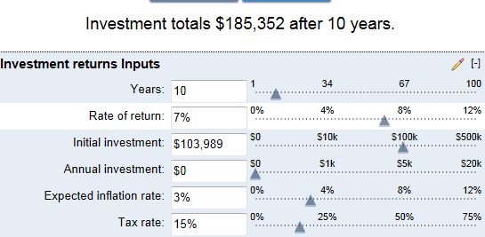

Information in bankrate.com is highly recognized from all business corporations. Bankrate develops and provides web services to over 75 co-branded websites with online partners, including some of the most trusted and frequently visited personal finance sites on the Internet such as [Yahoo!](http://en.wikipedia.org/wiki/Yahoo%21), [AOL](http://en.wikipedia.org/wiki/AOL), [CNBC](http://en.wikipedia.org/wiki/CNBC) and [Bloomberg](http://en.wikipedia.org/wiki/Bloomberg_L.P.). In addition, Bankrate licenses editorial content to over 100 newspapers on a daily basis including [The Wall Street Journal](http://en.wikipedia.org/wiki/The_Wall_Street_Journal), [USA Today](http://en.wikipedia.org/wiki/USA_Today), and [The New York Times](http://en.wikipedia.org/wiki/The_New_York_Times).

**VI. CONCLUSION**

Celestial is not like any other apparel stores that lack innovation, passion, and/or customer-first mindset. Celestial carries the body, heart, and mind of a business in perfect unison. Celestial’s capability to break-even in the 11th month and generate $100,000+ of profit in the third year are only few of the achievements Celestial forecasts.

Celestial provides only the top 20 name brands of the month and corporate Celestial brand. Having top 20 name brands make every single item in stock reliable and trendy. Personal Celestial products are also created after hearing the voices of the customers through personal suggestion and surveys online or in person. The uniqueness doesn’t stop here. All employees are professional trained to master the selling process. This enables all customers into a potential business relationship. With the theme of universe, Celestial will draw in the customers to be mesmerized at the selections that Celestial has. Lastly, variety of promotions helps support the growth of Celestial. The strategic use of even the smallest promotions make Celestial a dominant competitor in the apparel industry.

Why wouldn’t anyone want to invest on a business with great promises? Investment of $103,999 can lead to Celestial’s planned success. What is in it for you, the investor, is the return of $81,363 in those years and on-going partnerships with Celestial. Celestial has experiences that qualify and the motivations that drive, ensuring the value above to come alive. And for the apparel industry, Celestial is more than just money; it is transformation.

[](http://www.google.com/url?sa=i&rct=j&q=&esrc=s&frm=1&source=images&cd=&cad=rja&uact=8&docid=Glea8I-YtfK7zM&tbnid=f7FfN3OosF7icM:&ved=0CAUQjRw&url=http://sullivanpratt.com/&ei=-gVtU8K7BoeJlAWmkoDAAQ&bvm=bv.66330100,d.cGU&psig=AFQjCNExrlp7n2s9Jk-c8OOJHx3GRXexmQ&ust=1399740280814648)

**VII. BIBLIOGRAPHY**

Berman, Barry, and Joel R. Evans. *Retail Management: A Strategic Approach*. 8th ed. New Jersey: Prentice Hall, 2012. Print.

"Bothell (city), Washington." *United States Census Bureau*. U.S. Census Bureau, 27 Mar. 2014. Web. 1 May 2014. <http://quickfacts.census.gov/qfd/states/53/5307380.html>.

Farese, Lois Schneider, Grady Kimbrell, and Carl A. Woloszyk. *Marketing*

*Essentials*. 3rd ed. California: Glencoe/McGraw Hill Division, 2002.

Print.

"Fashion: Spotlight on Statistics." *Bureau of Labor Statistics*. U.S. Bureau of Labor Statistics, June 2012. Web. 28 Apr. 2014. <http://www.bls.gov/spotlight/2012/fashion/>.

Larson, Mark, and Patrick Dolan. "2013 Retail Industry Outlook Survey." *KPMG*. KPMG LLP, 2013. Web. 28 Apr. 2014. <https://www.kpmg.com/US/en/IssuesAndInsights/ArticlesPublications/Documents/retail-outlook-survey-2013.pdf>.

Lewis, Mark. "Zumiez Founder Tom Campion Shares Insight on Building a Sales Based Culture, Canadian Expansion, and Giving Back." *Transworld Busienss*. GrindMedia, 28 Oct. 2010. Web. 28 Apr. 2014. <http://business.transworld.net/50648/features/catching-up-with-zumiez-founder-tom-campion/>.

Nguyen, Mary. Personal interview. 12 Apr. 2014.

Walano, Rose. "April: A Month's worth of #OOTD Ideas." *Seventeen* Mar. 2014: 12-19. Print.

**VIII. APPENDIX**

List of vendors

|  |  |
| --- | --- |
| Diamond  Obey  Primitive  K Original  On the Byas  Riot Society  RVCA  Zine  Neff  Vans  Nike  G-Shock  American Eagle  Abercombie & Fitch  Hollister  Levi’s  Aeropostale  Kelvin Klein  Pink  Lululemon  Forever 21 | H&M  La Hearts  Almost Famous  Toms  Converse  North Face  Claire’s  Skyline Socks  Burberry  Uggs |

Celestial Layout

40ft ↔

50ft ↑↓

Fitting Area

Female Restroom

Male Restroom

Fitting Area

Cash Register

Hangers

Display Table

WOMEN

MEN

Display Table

Shelf

Door

Sidewalk

Parking lot

Features and Benefits of Celestial

|  |  |
| --- | --- |
| **Features** | **Benefits** |
| * Celestial dims the light so it is slightly dark in the store. | * Customers can shop on their own without eyes getting pointed at them. |
| * Celestial is constellation themed. | * The lighting makes the customer feel mythical. |
| * Celestial provides corporate brand and name brand. | * Customers have options that aren’t available in any other store. |
| * Celestial has employees always standing around to greet and converse with the customers. | * Customers feel comfortable and important to be in the store. |
| * Celestial asks the customers for a favorite design or design ideas. | * Customers’ opinions are being heard, therefore they get what they want. |
| * Celestial has a blog page along with the website. | * Customers can directly share their opinion about the clothes without getting judged. |
| * Celestial hands out coupons at the end of every transaction. | * Customers can save their money on their next purchase with Celestials. |
| * Celestial is located between three cities on a main road. | * Customers feel the ease of accessing the business. |
| * Celestials provide popular music with great quality. | * Customers enjoy the experience in Celestial with pleasing music to their ears. |
| * Celestials provide self-checkout under assistance. | * Customers find cash register interesting and it also is efficient for the customers. |

**Brian Moon**

**2111 196th St SW   
Lynnwood, WA 98036**

**425/368-8956 cell brianmoon150920@gmail.com**



**Press Release**

Celestial’s Viral Fashion:

Fly to the Moon, Wear the Universe

**April 8, 2014**

**Celestial**, with innovative ideas and incomparable passion towards the fashion industry, attempts to enter the market with great plans. Aiming to attract all the ages 13-21 across the King Country and Snohomish Area, Celestial provides name brands like ‘Diamond’ and its own corporate brand product which no store has ever seen. Giving their customers variety of options to choose from, Celestial is projected to provide one of the best customer services. With this positive mindset, Celestial desires to create a celestial place with inimitable products.

**Celestial** started on its exploration to gain customer base by approaching prospects from schools with engaging questions and facts. Celestial got their hands on producing personal brands based on the target markets’ voices and wants themselves. Celestial has also monitored the trend leader at each school therefore persuading the others to come in the store to be part of the new uprising trend. Celestial’s quest has been truly remarkable the past few months with numerous researches and it is worth talking about.

**Celestial** is committed to follow up and follow through their vision to create universal design and clothing. Their mission statement, *‘to generate both existing and personal branding to take the lead on the clothing trend,’* rises up high as it will be held up with high expectations soon with customer’s flowing in the store.

Further questions can be answered by Celestial in the contact above.

Promotional Examples

Business card: Business card will be distributed to possible vendors or customers in occasion.

Promotional Examples

Mail and Email (↓ left): Celestial will send out emails that are obtained through customer’s first transaction with the store. Emails often include discounts and the weekly or seasonal sales promotion that customers might be interested. This keeps the customers engaged with Celestial and make their visit again.

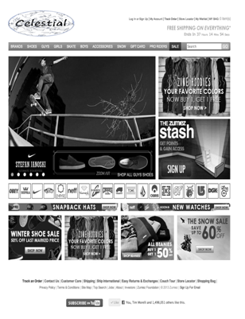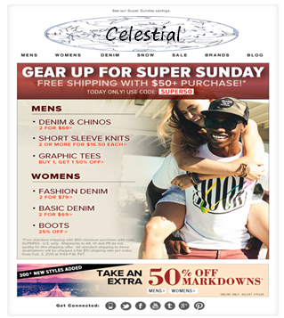

Website/Giveaway (↑ right): Interactive pages are available where customers can make suggestions for what they want Celestial to make. The tabs are very efficient in getting the customers to products they want. Online transactions are all free shipping. Giveaway is part of the website where customers who buys from Celestial will receive a code for possible gift cards within Celestial or for concert ticket. The giveaway promotion is advertised through other promotions shown.

Promotional Examples

Coupon: Coupons will be given in different occasions. Some will be mailed as a seasonal promotion to local addresses. This gets new customers or existing customers to be allured. Some are given to build customer relationship For example, a 10 percent off coupons will be given to the customer every transaction, but for a month later use. This keeps the customers coming back and the information are clearly written.



YouTube Ad: YouTube is where most viral videos are uploaded. YouTube gets millions of teenage viewers online every day. Buying a slot for YouTube ad that appears in the display box to the right, will draw the attention of teens. The unique selling points that the ad will show will get the teenagers to come to Celestial. The cost of this can be reduced by setting the ad so it only appears on videos that are related to fashion. This causes only the people who are already interested in clothing to see the great benefits Celestial provides.

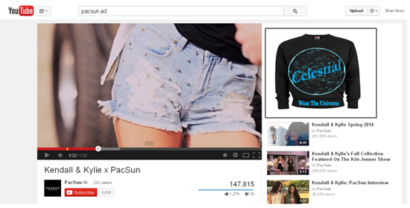

Promotional Examples

Google AdWord: Google AdWord is an advertisement slot in Google which can be bought so the link to a website can appear on the margins. By buying this advertisement all Google searchers can be unknowingly directed to the Celestial website. Celestial website will grab the attention the moment the screen shows up. The important aspect of Google AdWord is that the advertisement will only show up when the search is related to clothing. This is acceptable however since it is common for teenagers to look up clothing online.

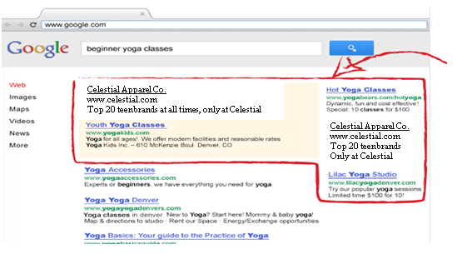

Radio Ad: Radio Ad will be an effective promotion especially because most teenagers listen to music during transportation. Celestial will purchase a time slot for advertisement during the middle of the first year and the second year on when it is affordable. In popular stations like Cube 93.3, Celestial will share its unique selling points and the sales promotion that possible prospects would like to hear. This will inform anyone from the Washington area which broadens the demographics more than ever. This is definitely another strong promotion.

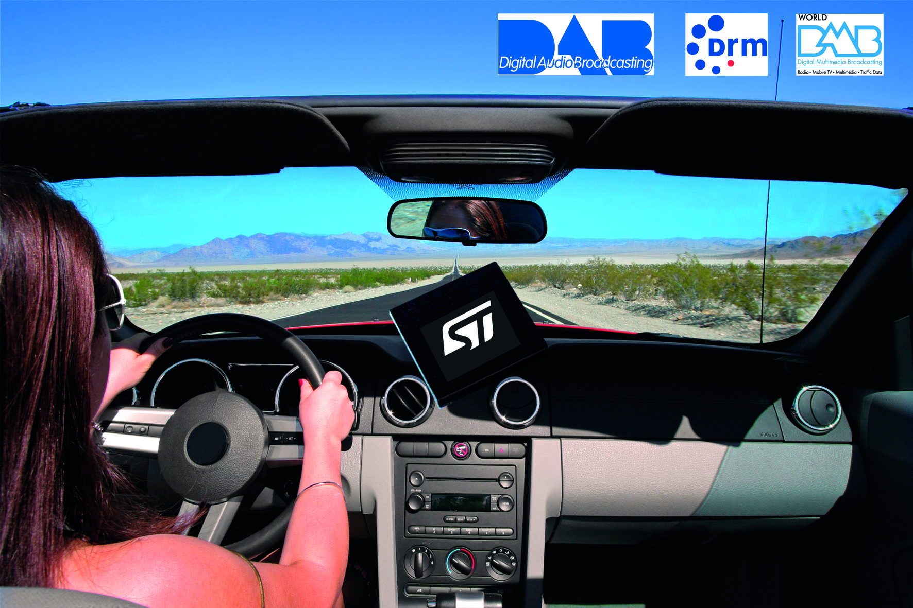

This is Cube 93.3. 2pm is brought to you by your own local apparel store, Celestial, “wear the universe.”

Promotional Examples

Small billboard: Small billboards like shown below will be set up in busy streets like the Bothell-Everett Highway. This will inform everyone in the local area the existence of Celestial and what Celestial has to offer. Billboards are hard to miss and utilizing this fact can really put the business out there in the public.

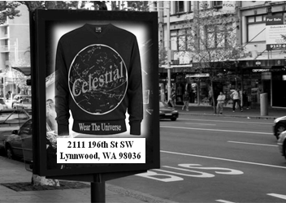

Bus Banner: Since multiple bus routes and community transits exist in the Bothell to Lynnwood area, having bus banners can lead to immense growth in publicity. Being stuck in traffic or being stopped for a bus stop almost forces the drivers to wander their eyes to the advertisement.

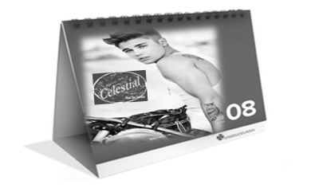Calendar: Calendar is a very favored item towards the end of the year. Handing out extra calendars with pictures of Celestial can cause customers to pass on the calendar to others and require them to gain knowledge of Celestial.

List of Items Needed to Start Celestial

|  |  |  |
| --- | --- | --- |
| 1. T-shirt 2. Dry-fit shirt 3. Tank tops 4. Cargo shorts 5. Skinny jean 6. Straight jean 7. Boot cut jean 8. Leggings 9. Yoga pants 10. Sweatpants 11. Crew sock 12. Snapback 13. Shades 14. Denim jacket 15. Leather jacket 16. Fleece jacket 17. Sweatshirt 18. Crewneck 19. G-shock 20. Compression shorts 21. Perfume 22. Cologne 23. High tops 24. Skirt 25. Dress 26. Vest 27. Flats 28. Shoes 29. Cardigan 30. Backpack 31. Belt 32. Phone case 33. Organizer 34. Cashier 35. Model 36. Boots 37. Swimwear 38. Underwear 39. Coat 40. Sweater 41. Beanie 42. Hat 43. Gloves 44. Overalls | 1. Button up 2. Flannel 3. Scarf 4. Lanyard 5. Accessory 6. Branded bag 7. Paper bag 8. Plastic bag 9. Remodeling 10. Property lease (2000ft2 = 5000 per month) 11. Operative department 12. HR department 13. Business professionals 14. Financial department 15. Security camera 16. Security censor 17. Property Insurance 18. Electricity 19. Gas 20. Water 21. License 22. Permits 23. Billboard 24. Posters 25. Commercial 26. Web page 27. Open sign 28. Automatic door 29. Logo 30. Phone 31. Internet 32. Shelf 33. Lighting 34. Lamps 35. Constellation 36. Mirror 37. Carpet 38. Sound system 39. Hanger 40. Wall display 41. Cabinets 42. Cash register 43. Fitting room | 1. Bench 2. Couch 3. Mannequin 4. Décor 5. Desk 6. Printer 7. Office supplies 8. Cleaning supplies 9. Bathroom 10. Soap 11. Paper towel 12. Wages ($15-$20) 13. Draw ($3000 per month) |